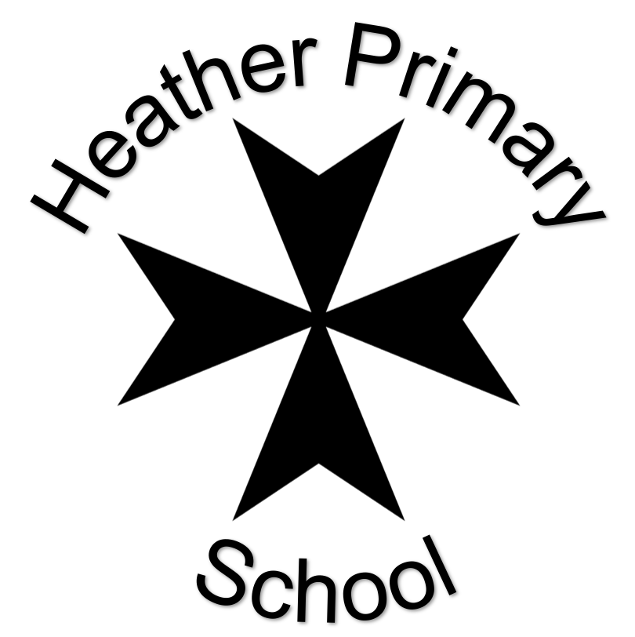

Home Work Booklet

Donaldson Class
Autumn 2020

Dear Parents
This is your child’s homework for the term.
Listed on the next page is all of your child’s homework for the term.
There are two weeks to plan and complete each piece of homework – giving the children plenty of time and flexibility to plan when to complete their work. Try and not leave it to the last minute!!
Your child can choose the format of their homework – pictures, poster, 3D creation etc.
I encourage the children to take pride and responsibility for their work. We have paper in the classroom if your child needs some extra pages.
This is your child’s book, so naturally it needs to be them who needs to complete the work.
Please remember:
- Late homework will be acknowledged but not necessarily marked;
- Printed off sheets straight from internet are not acceptable;
- Handwriting should be at the expected standard as expected in class:
- Homework that is done on paper must be no more than two side of A4;
- If you require paper etc to complete the homework, please ask.

This term the home work choices are:
Literacy:  Draw a picture/ write a list of your favourite food and drink. | Understanding the World:  Bring in a photograph of you when you were younger and tell us some of the ways you have changed. | Expressive Arts & Design:  Draw/ paint a picture of your favourite toy. You could have a go at labelling with some adult support.
Maths:  Use some paint to make handprints of the people in your family. Can you put them in order to show the smallest to largest hand? | Expressive Arts & Design:  Create a self-portrait of yourself by drawing, painting or a collage. Look in a mirror to check your features and try to use the right colours. | Understanding the World:  Talk to somebody at home about what you would like to do when you grow up. You could draw a picture and find out information about the job role.
Understanding the World:  Find out about your 5 senses through listening and observing on walks, smelling and tasting different foods and feeling different textures. You might like to take some photos or make a collage of the different textures you find. | Literacy:  Retell the story of Owl Babies to a family member. You could make some story props for acting out the story. | Maths:  Can you make a tower/ line with exactly 10 bricks or toys?
Maths:  Go on a number hunt. Ask an adult to write down numbers 0-5 on some card/paper and hide them in the garden. Can you find them and place them in order? | PSHE:  Draw a picture that shows all of the people that are special to you. | Literacy:  Can you remember the characters that are in Funny Bones? You could have a go at drawing and labelling them.
Task | Homework Set | Date Due
Choice | 8th Sept | 21st Sept
Literacy | 28th Sept | 12th Oct
Choice | 26th Oct | 9th Nov
Maths | 16th Nov | 30th Nov

Please keep practising your phase 2 phonics sounds and tricky high frequency words:

Phase 2 Phonemes:
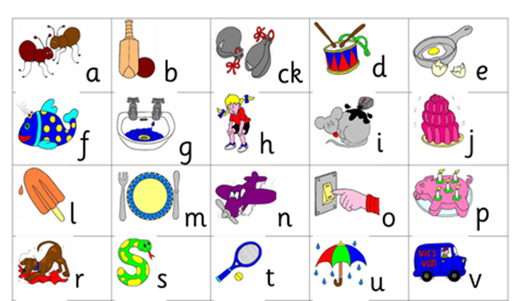

Tricky Words:

