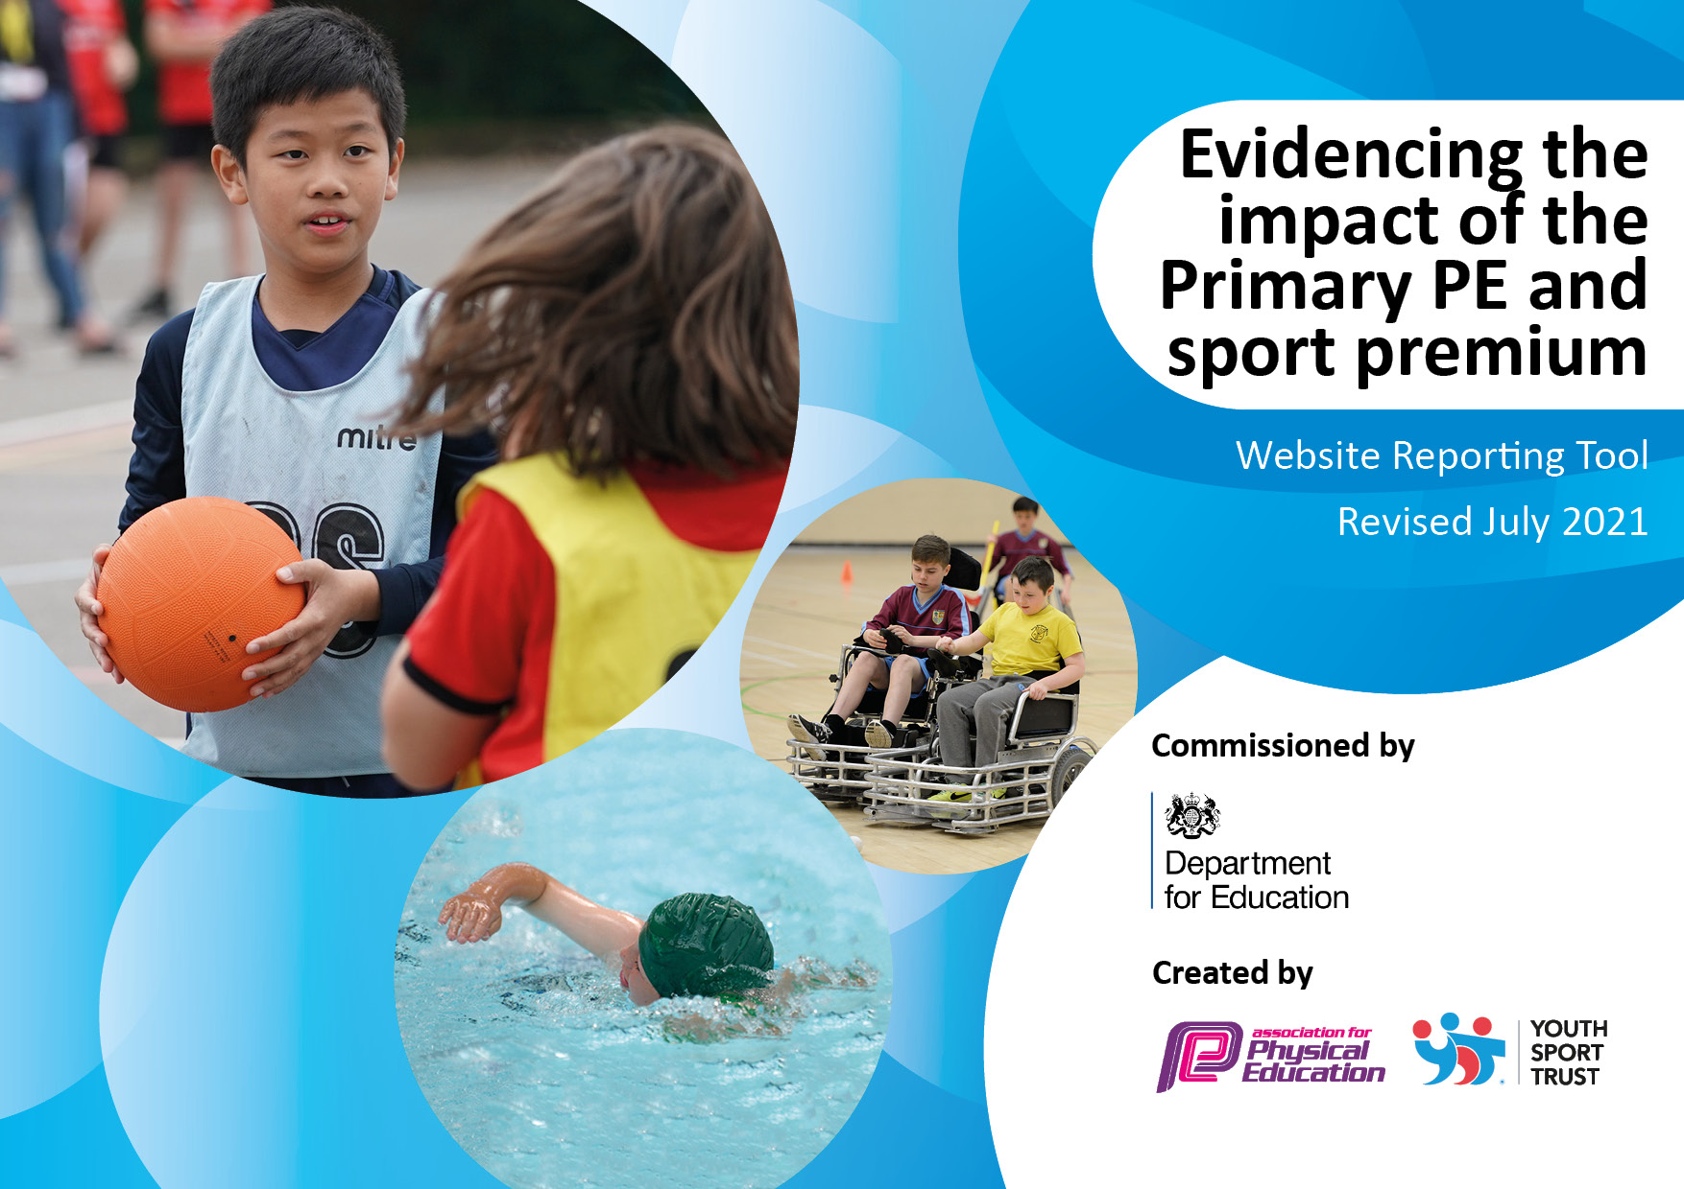

**Heather Primary School**

**2022-23**

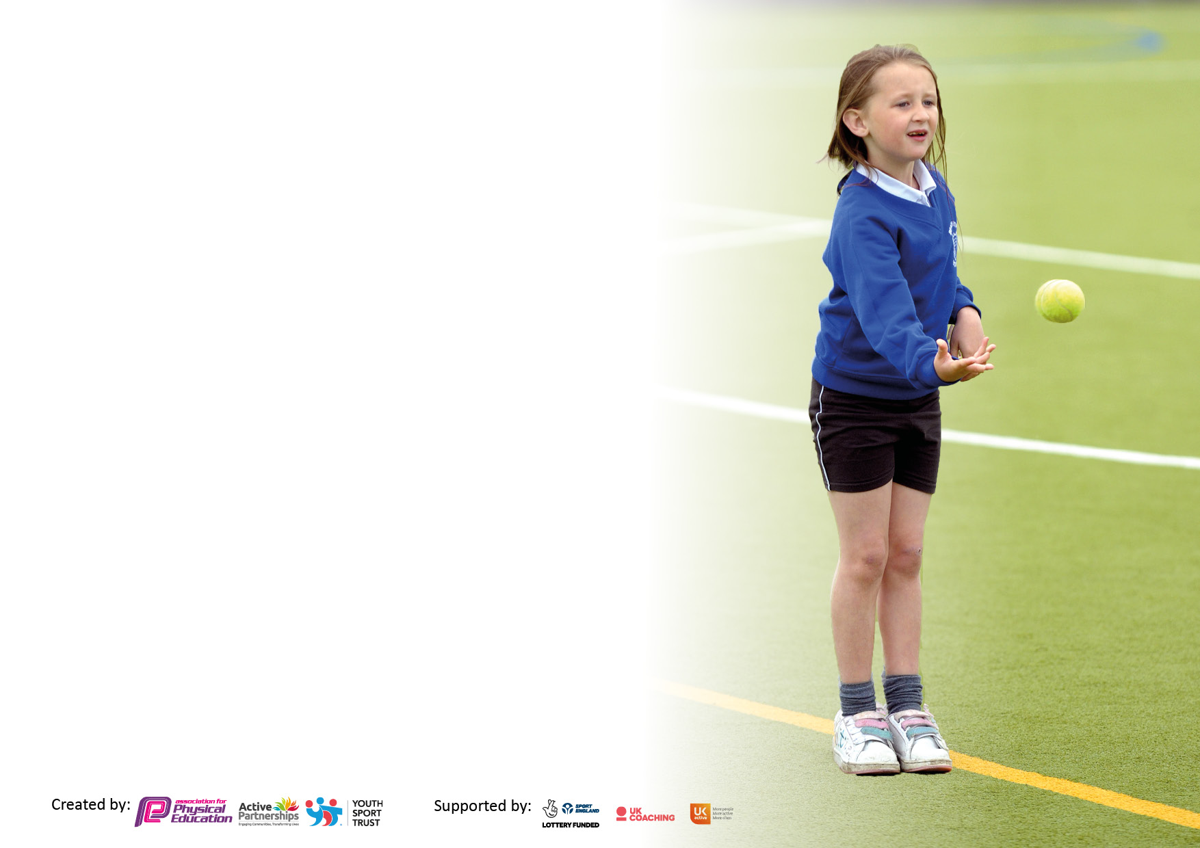

It is important that your grant is used effectively and based on school need. The Education Inspection Framework makes clear there will be a focus on **‘whether leaders and those responsible for governors all understand their respective roles and perform these in a way that enhances the effectiveness of the school’**.

Under the Quality of Education Ofsted inspectors consider:

**Intent** - Curriculum design, coverage and appropriateness

**Implementation** - Curriculum delivery, Teaching (pedagogy) and Assessment

**Impact** - Attainment and progress

To assist schools with common transferable language this template has been developed to utilise the same three headings which should make your plans easily transferable between working documents.

Schools must use the funding to make **additional and sustainable** improvements to the quality of Physical Education, School Sport and Physical Activity (PESSPA) they offer. This means that you should use the Primary PE and sport premium to:

* Develop or add to the PESSPA activities that your school already offer
* Build capacity and capability within the school to ensure that improvements made now will benefit pupils joining the school in future years
* The Primary PE and sport premium should not be used to fund capital spend projects; the school’s budget should fund these.

Pleasevisitgov.ukfortherevisedDfEguidanceincludingthe5keyindicatorsacrosswhichschoolsshoulddemonstrate animprovement.Thisdocumentwillhelpyoutoreviewyourprovisionandtoreportyourspend.DfEencouragesschools to use this template as an effective way of meeting the reporting requirements of the Primary PE and sport premium.

We recommend you start by reflecting on the impact of current provision and reviewing the previous spend.

Schools are required to publish details of how they spend this funding, including any under-spend from 2019/2020, as well as on the impact it has on pupils’ PE and sport participation and attainment. **All funding must be spent by 31st July 2022.**

We recommend regularly updating the table and publishing it on your website throughout the year. This evidences your ongoing self-evaluation of how you are using the funding to secure maximum, sustainable impact. Final copy must be posted on your website by the end of the academic year and no later than the 31st July 2021. To see an example of how to complete the table please click HERE.

|  |  |
| --- | --- |
| Support for review and reflection – considering the 5 key indicators from DfE, what development needs are a priority for your setting and your students now and why? Use the space below to reflect on previous spend, identify current need and priorities for the future. | |
| Key Achievements to date | Areas for further improvement |
| * All children from year 1-6 participate in 2 hours of PE a week. This gives the children the change to experience and learn in a wide range of sports. * Children in EYFS, have one hour of PE session a week, along with gross and fine motor activities within continuous provision, including bikeability and Smart Moves as well as a forest school session each week. * Our lunchtime supervisors and bronze ambassadors work well to ensure that there are different physical activities on offer over lunch times. * Extra curriculum clubs after school run all year round offering a range of different sports * Continued to raise the profile of sporting achievements through recognition in assemblies and promoting achievement and participation on social media and messaging systems. * CPD continues to be put in place for teaching staff where required. * Smart moves has been introduced in summer term to develop core strength, gross motors skills etc in targeted children across the school. * A full sports day was organised, all children participate in a range of races - families and friends were invited to enjoy the children’s achievements * Where capacity allows, a large range of sporting events have been entered for with great success. | * Raise the profile of certain after school clubs to ensure a better up take * Offer a range of clubs to targeted groups to increase their participation in different sports. * A more team teach style approach in coach led session to allow teachers to put in place skills acquired through CPD in a supportive environment * Ensure year 6 children can perform self-safe rescue in different water-based situations. |

Created by: Supported by:

**Details with regard to funding**

Please complete the table below.

|  |  |
| --- | --- |
| Total amount carried over from 2019/20 | £ 3555.00 |
| Total amount allocated for 2020/21 | £16,920.00 |
| How much (if any) do you intend to carry over from this total fund into 2021/22? | £ 2,252.00 |
| Total amount allocated for 2021/22 | £16,900.00 |
| Total amount of funding for 2021/22. To be spent and reported on by 31st July 2022. | £ 19,152.00 - total on sheet 14231.53 |
| Total amount allocated for 2022/23 |  |

**Swimming Data**

Please report on your Swimming Data below.

|  |  |
| --- | --- |
| Meeting national curriculum requirements for swimming and water safety.  N.B. Complete this section to your best ability. For example you might have practised safe self-rescue techniques on dry land which you can then transfer to the pool when school swimming restarts.  **Due to exceptional circumstances priority should be given to ensuring that pupils can perform safe self rescue even if they do not fully meet the first two requirements of the NC programme of study** | 13 children in the year 6 cohort for 21/22 |
| What percentage of your current Year 6 cohort swim competently, confidently and proficiently over a distance of at least 25 metres?  **N.B.** Even though your pupils may swim in another year please report on their attainment on leaving primary school at the end of the summer term 2021.  Please see note above | 93 % |
| What percentage of your current Year 6 cohort use a range of strokes effectively [for example, front crawl, backstroke and breaststroke]?  Please see note above | 77%  13 children in the cohort |
| **What percentage of your current Year 6 cohort perform safe self-rescue in different water-based situations?** | 0% |
| Schools can choose to use the Primary PE and sport premium to provide additional provision for swimming but this must be for activity **over and above** the national curriculum requirements. Have you used it in this way? | No – hope to be able to provide this next year in conjunction with another local school. |

**Action Plan and Budget Tracking**

Capture your intended annual spend against the 5 key indicators. Clarify the success criteria and evidence of impact that you intend to measure to evaluate for pupils today and for the future.

|  |  |  |  |  |
| --- | --- | --- | --- | --- |
| **Academic Year:** 2021/22 | **Total fund allocated: £16900** | **Date Updated: 7th July** | |  |
| **Key indicator 1:** The engagement of all pupils in regular physical activity – Chief Medical Officers guidelines recommend that primary school pupils undertake at least 30 minutes of physical activity a day in school | | | | Percentage of total allocation: |
| 3.4% |
| **Intent** | **Implementation** | | **Impact** |  |
| Your school focus should be clear what you want the pupils to know and be able to do and about  what they need to learn and to  consolidate through practice: | Make sure your actions to achieve are linked to your intentions: | Funding allocated: | Evidence of impact: what do pupils now know and what can they now do? What has changed? | Sustainability and suggested next steps: |
| Each pupil to receive 2 hours curriculum PE each week. In addition to this after school and lunchtime clubs with a PE focus are provided on a regular basis.  Clubs include: football, archery, table tennis, netball, dodge ball | Equipment purchased for PE to be able to deliver a broad curriculum on site (see budget breakdown). | £431.53  £150.0 PE co-ordinator, curriculum development | All pupils have had the experience of a broad curriculum giving them experience and enabling them to develop their skills in all areas | To look at the curriculum again to ensure that a wide range of games/activities are provided in PE curriculum time offering variety and breadth. |
| Sports achievements both in and out of school are celebrated when they occur. | Display board in the hall is used to highlight sport at Heather – success, achievements and photos.  PLT takes responsibility of promoting sports  Certificates are awarded for sporting achievements  Children create powerpoints to share their journey and success. | £300 - resources | Encourages and inspires all children.  Children involved are proud to share their achievement and successes – both in and out of school. | All staff see the benefits of the raised profile of sport and its importance for health and well-being. |
| To provide adequate kit for children so that it is not a barrier for participation | Purchase uniform where required.  Purchase specialist kit for competitions so that all children chosen can take part. | £500 | Children are proud to represent the school in the right kit. | Children to continue to enjoy competitive sporting experience. |
| **Key indicator 2:** The profile of PESSPA being raised across the school as a tool for whole school improvement | | | | Percentage of total allocation: |
| % |
| **Intent** | **Implementation** | | **Impact** |  |
| Your school focus should be clear what you want the pupils to know and be able to do and about  what they need to learn and to  consolidate through practice: | Make sure your actions to achieve are linked to your intentions: | Funding allocated: | Evidence of impact: what do pupils now know and what can they now do? What has changed? | Sustainability and suggested next steps: |
| Provide a more sustained amount of time for swimming lessons taught by qualified swimming teachers. | Extra swimming coaches employed to enable all pupils years 3-6 to have a longer period of swimming lessons | £1832.00  Tuition/coach  £720.00  travel | Raised 5 of pupils in year 6 achieving the required standard for swimming performance due to disjointed swimming access during the COVID 19 disruption. | To continue with swimming lesson across all of key stage 2 in next academic year and to use the funding to perhaps add in some extra sessions for non-swimmers. |

|  |  |  |  |  |
| --- | --- | --- | --- | --- |
| **Key indicator 3:** Increased confidence, knowledge and skills of all staff in teaching PE and sport | | | | Percentage of total allocation: |
| 32% |
| **Intent** | **Implementation** | | **Impact** |  |
| Your school focus should be clear | Make sure your actions to | Funding | Evidence of impact: what do | Sustainability and suggested |
| what you want the pupils to know | achieve are linked to your | allocated: | pupils now know and what | next steps: |
| and be able to do and about | intentions: |  | can they now do? What has |  |
| what they need to learn and to |  |  | changed? |  |
| consolidate through practice: |  |  |  |  |
| To up skill all staff and pupils in all PE subject areas in order that pupils may reach a competent level akin to the year group expectations | Coaches employed throughout the academic year for all classes - teachers are present at all of these sessions and it is used as their CPD where they can learn from excellent PE practitioners and take that forward in to their own teacher led PE sessions. | £ 5328.00  L. Thornley gym  Coach Unlimited  Mr PE  Smart Moves  Road Safety | Broader PE curriculum delivered to all classes.  Evidence collected for the school games mark through pupil questionnaires in key stage 2 shows an overall positive attitude and increased enjoyment and participation in sport and children then seeking to continue this interest in out of school sports activities. Good level of success in local competitions in basketball, curling and cricket | To continue with regular coaches in school and for use in after school clubs following a similar pattern next academic year with a large focus on team teach with in the lessons as well as CPD for all teaching staff. |
| **Key indicator 4:** Broader experience of a range of sports and activities offered to all pupils | | | | Percentage of total allocation: |
|  |
| **Intent** | **Implementation** | | **Impact** |  |
| Your school focus should be clear | Make sure your actions to | Funding | Evidence of impact: what do | Sustainability and suggested |
| what you want the pupils to know | achieve are linked to your | allocated: | pupils now know and what | next steps: |
| and be able to do and about | intentions: |  | can they now do? What has |  |
| what they need to learn and to |  |  | changed? |  |
| consolidate through practice: |  |  |  |  |
| Additional achievements:  Additional achievements:  We have also had coaching from Leicester Riders and Chance to shine cricket. | All pupils accessed at least half a term of coaching in cricket,  All pupils in Key stage 2 had basketball coaching for a term | £ £700.00 Riders  £285.00 – coach travel and competition cost | Participation and interest in basketball has improved. Basketball skills have increase across the whole of key stage 2 pupils entered the basketball tournament (2 teams). Third place in NWLSSP competitions for both cricket and basketball.  Fourth place for the year 3/4 team at the Leicester Riders Basketball tournament  Several children have now joined a local Cricket club. | Leicester Riders and Chance to Shine Cricket to be invited in again next academic year.  Continue to assess local competitions to increase participation. |

|  |  |  |  |  |
| --- | --- | --- | --- | --- |
| **Key indicator 5:** Increased participation in competitive sport | | | | Percentage of total allocation: |
| 27 % |
| **Intent** | **Implementation** | | **Impact** |  |
| Your school focus should be clear | Make sure your actions to | Funding | Evidence of impact: what do | Sustainability and suggested |
| what you want the pupils to know | achieve are linked to your | allocated: | pupils now know and what | next steps: |
| and be able to do and about | intentions: |  | can they now do? What has |  |
| what they need to learn and to |  |  | changed? |  |
| consolidate through practice: |  |  |  |  |
| Following the Covid pandemic it was our intention this academic year to be more involved with the wider sporting community by continuing with the membership of NWLSSP to whom we affiliate each year. | Through the buy in to NWLSSP option 3 we are able to access CPD, competitions, festivals and Curriculum development time.  We have participated in Key stage 1 multi-skill festivals (all Key stage 1 pupils).  Year 3-6 pupils have had the opportunity to take part in various competitive sports organised through NWLS to include - basketball, hockey, swimming, curling (SEND) orienteering, rugby, area athletics, personal best festival | £ £3475.00  NWLSSP  coaches to events  £1095.00 | All pupils have had the opportunity to take part in school-based activities and off site sessions and competitions. Resilience, teamwork and co-operation has improved through the teaching and delivery of PE- linked to Heather character traits. | To continue with NWLSSP at the current buy in level to access teacher support network meetings and access to events and competitions where staffing capacity allows |
| We have also run a school sports day again this year inviting parents/carers in for the first time since the pandemic. This was very positive and it enabled parents to see their children perform. |  |  |  |  |

|  |  |
| --- | --- |
| Signed off by | |
| Head Teacher: |  |
| Date: | 22/7/22 |
| Subject Leader: |  |
| Date: | 8/7/22 |
| Governor: |  |
| Date: | 29/7/22 |