Homework – Spring
 | Task | Set | Due
Topic/ English | Choose an activity from the list below. | 10/1/2019 | 24/1/ 2019
Maths | Play a game from the Gareth Metcalfe I See Maths website and rate it out of 10 – don’t forget to give a reason for your choice.  http://www.iseemaths.com/games-resources/  To access, select ‘free resources’* | 31/1/2019 | 14/2/2019
Topic/ English | Choose an activity from the list below. | 28/2/2019 | 13/3/2019
Maths | Play a different game from the Gareth Metcalfe I See Maths website and rate it out of 10 – don’t forget to give a reason for your choice.  http://www.iseemaths.com/games-resources/  To access, select ‘free resources’* | 20/3/2019 | 3/4/2019
Topic/ English Choices
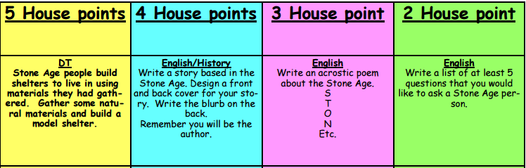
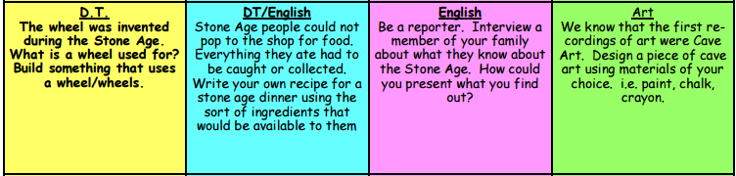
*Please note, if you do not have access to the internet and/ or a printer, please ask for a paper-based game

