Heather Primary School –
Homework Booklet

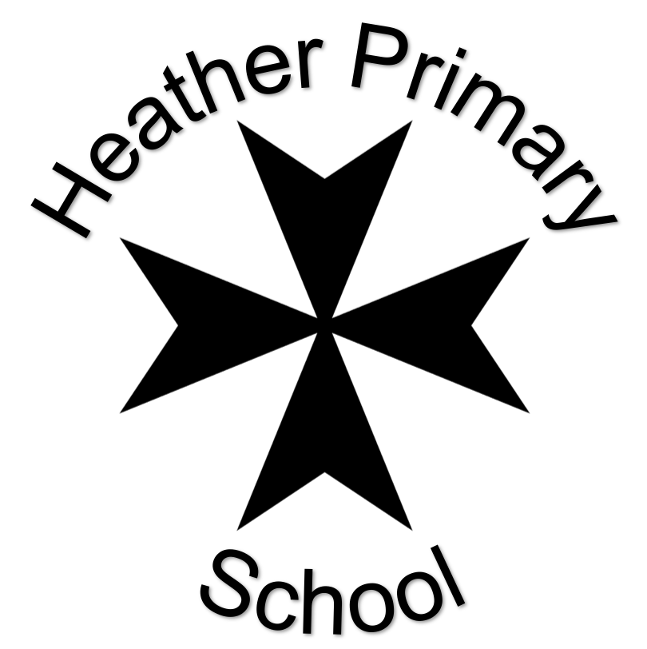

Summer 2022
Class: Dragonfly Class – Year 5/6

 | Task | Set | Due
 | Choose an activity from the list below. | Friday 29th April | Monday 9th May
 | Choose an activity from the list below. | Monday 16th May | Monday 6th June
 | Choose an activity from the list below. | Monday 13th June | Friday 27th June

Choices
English
Write a description of an imaginary monster – use all of your descriptive skills – personification (e.g. flames danced from its nostrils); alliteration (Fiery flames); similes (its eyes were like deep, black pits); metaphor (its claws were deadly knives) and so on… | Write a poem about your favourite place – make it descriptive and special! | Write a newspaper article about a monster rampaging through a local town or village – it needs a headline, introductory paragraph and quotes from eye-witnesses. Remember: what? Where? Why? Who? When?
Maths: review activities.
Shape and space: make a model made up of 3D shapes – it could be a fantasy building, a robot, a spaceship…use your imagination. Try to use a protractor, pair of compasses and a ruler if you can. Take a photo as evidence. | Find a recipe that includes measurements of capacity (ml / fl oz), length (mm / cm), weight (oz, g, lb etc). take photos or bring in your creation. | Create a survey (traffic, garden birds…) of your own choice to show off your data handling skills – use percentages, bar charts / line graphs / pie charts / fractions etc to show your results.
Other Subjects
Create a model of the Egyptian pyramids or another aspect of Egyptian life. | Write about a famous river of the world – include a map of where it is in the world and key facts. | Copy a picture by Monet – try to make it as similar as possible. You could cut a picture of one of his paintings in half and then draw the other half back in yourself.

