My Writer’s Manual
Name…………………

Spellings

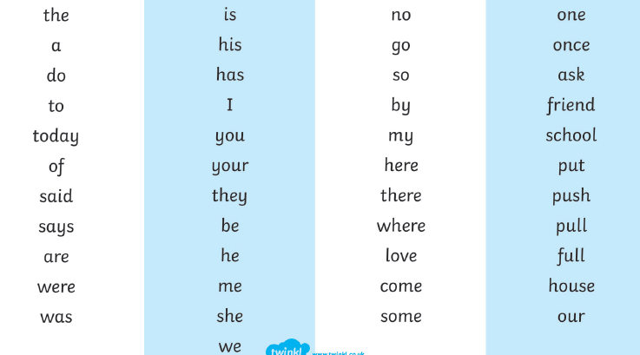

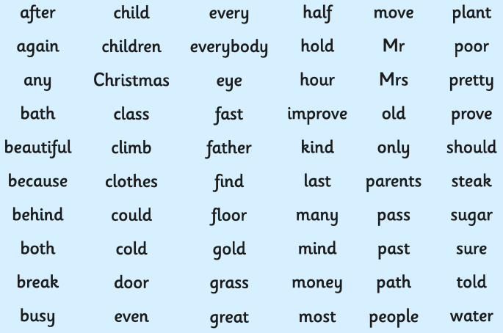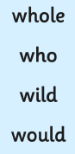

Punctuation

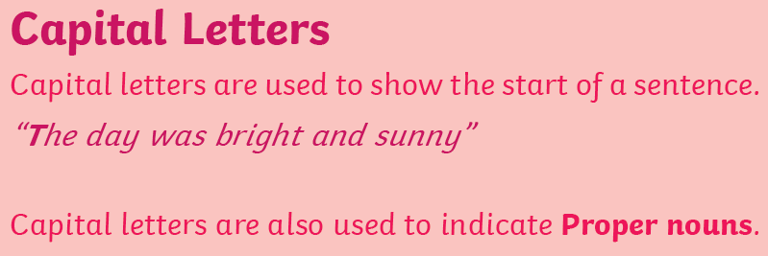

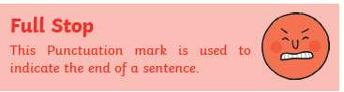

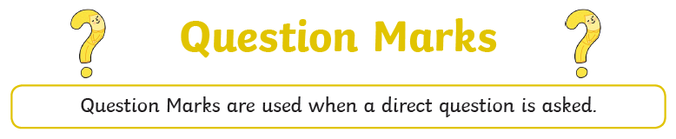

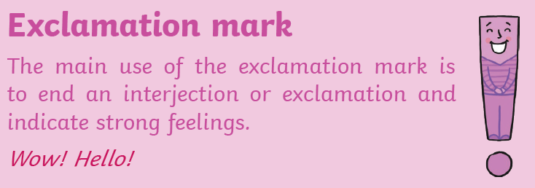

Sentence openers
I must remember to vary my sentence openers. Can you think of some good sentence openers? You might want to magpie some from the books you are reading.
Verb opener (doing word– sitting, sleeping…)

Preposition opener (position – on, above…)

Adverb opener (how or when – slowly, just then…)

Conjunctions
Joining two sentences together.
Co-ordinating conjunctions

and but or so

Subordinating conjunctions

because as when if where

Vocabulary

Words to create a happy atmosphere

Words to create a calm atmosphere

Words to create a scary atmosphere

Words to create a busy atmosphere

Better words
get
take
said
nice
good
bad

New words I like
Word | Definition

