My Writer’s Manual
Name…………………

Spellings I should know…

Year 1
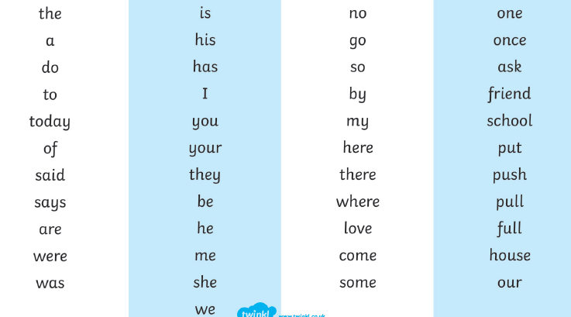

Year 2
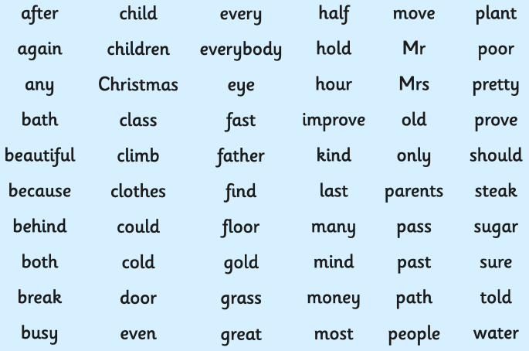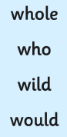
Year 3 and 4
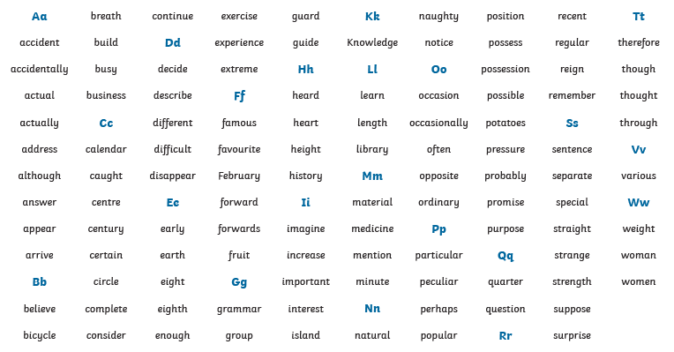

These spellings are only the common exception words. You must also apply the spelling rules in your journal to other spellings.
Don’t forget to practise over the words you are unsure of using look, cover, write.

Punctuation
I should be able to use the following punctuation correctly in my writing.
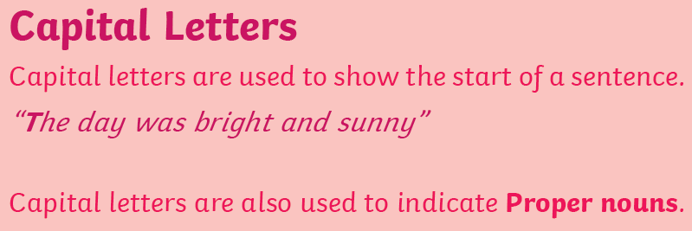

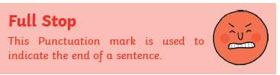

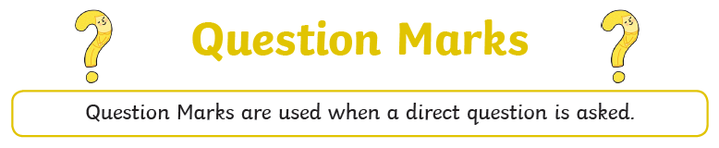

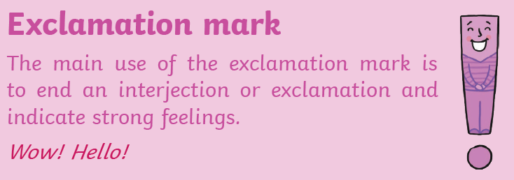

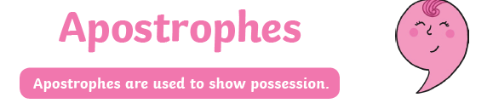
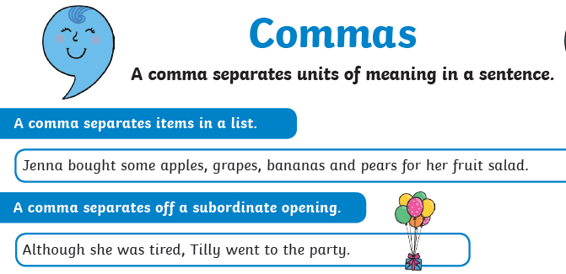

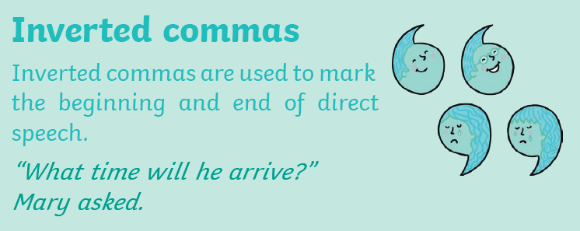

Sentence openers
I must remember to vary my sentence openers. Can you think of some good sentence openers? You might want to magpie some from the books you are reading.
Verb opener

Prepositional opener

Subordinate clause opener

Adverbial opener

Time – when

Reason - why

Manner - how

Place – where

I must try to extend some of my sentences with additional ideas and use a conjunction for these.
Co-ordinating conjunctions

for - used to give a reason for something
and – to join two different ideas together
nor – neither option
but – to give an exception
or – to give another option
yet – to give an exception
so – to give a reason

Subordinating conjunctions

because – gives a reason
as – happens at the same time
when – gives the time or something else happens
if – depends on something happening
where – gives the place
whilst – happens at the same time
since – from that time onwards or gives a reason
although – happened anyway
even though – happened anyway
despite – happened anyway
unless – a reason for something not to happen

Vocabulary
You should always try to expand your vocabulary and use new words in your writing using the books you are reading to influence you choices. Use this section to magpie words from the books you read for you to use at a later date.
Words to create an exciting atmosphere

Words to create a calm atmosphere

Words to create a scary atmosphere

Words to create a busy atmosphere

Words to create a strange or unnerving atmosphere

Try to find better words from the books you read as alternatives to the ones below:
get
take
said
nice
good
bad

New words I like
Word | Definition

